Ch.5 Lab2 Exercises

# Task 1

Write a program and define a function called **evaluates** that combines two integer numbers with an operator that is given as a string "+", "-", "*", "/", or "**" (raising to a power) and print the result of evaluating the operator with the arguments.

For example, evaluate("**", 10, 2) should print 100.

**Implement the function using a match statement**

**Adit’s Note: I already did this?**

# 

**Sample:**



Use the samples included below.

|  |
| --- |

|  |
| --- |

|  |
| --- |

# 

# 

# Task 2:

Write a program that greets the user with optional greetings. Define a function greet that takes two parameters, the user’s name and an optional parameter that represents the greeting.

Set the second parameter to a default greeting of "Hello”.

In the main, you will ask the user for their name and their (optional) greeting phrase.

Your main function should query the input greeting and then invoke the greet function with the correct arguments.

**Sample Output:**

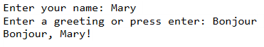

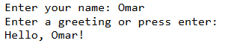

|  |
| --- |

|  |
| --- |

|  |
| --- |

# 

# Task 3:

Write a program that asks the user for an integer, then prints the number of digits in the number, the first digit, and the last digit. Your code should include the following functions:

* digits(num): calculates and returns the number of digits in the number
* firstDigit(num): returns the first digit in the number
* lastDigit(num): returns the last digit in the number
* printing(num): prints all the information for the number (no return)
* main(): prompt the user for the integer

**Note:**

In the main function, ask the user for the integer, then pass it as an argument to the printing function.

In the printing function, call all the other functions and print their returns. Use format specifiers.

Sample Output:

